**CORRUGATED ESTIMATING OPTIONS**

**Cad Integration for Esko Artios**

1. Advantzware imports data and link to images generated by the ArtiosCAD system.
2. Integration activated when the user elects to create a new estimate.
3. Prompts for the file path and name of the .ard file, quantity, category and style information from the user.
4. Automatically displays a list of forms in the ArtiosCAD file, allowing ASI user to specify blank information.
5. Advantzware pulls the new estimate information from the specified ArtiosCAD file, via CADx.
6. Process generates box image .jpg files, place them in the proper directory, and add a link to the image to the new Advantzware estimate.
7. New images can be added to the job tickets that Advantzware creates.

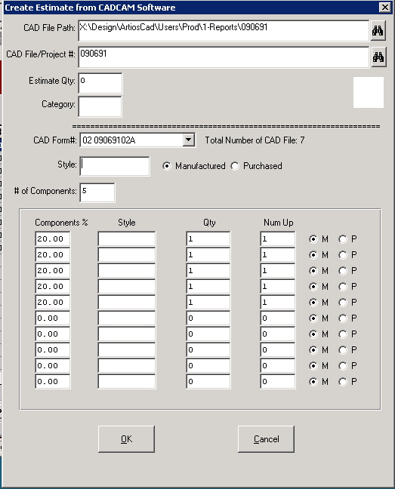

**CORRUGATED ESTIMATING OPTIONS - Single Item Estimates**

1. One Up with No Trim
2. Die Cuts with multiple Up
3. Two Piece Boxes and Fanfold Styles
4. Multiple Up with Trim Calculation

TWO PIECE BOXES – Estimate 1437

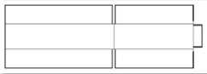



MULTIPLE OUT & SHEET CALC BUTTON for STOCKED SHEETS – Estimate 1431

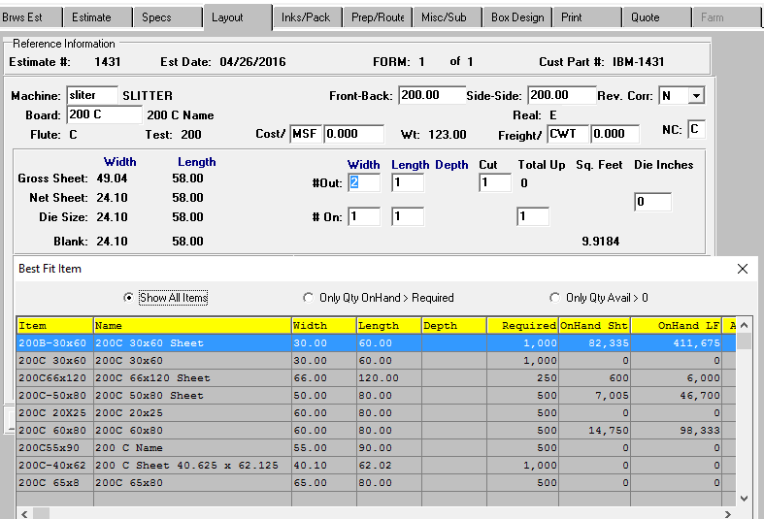

**CORRUGATED ESTIMATING OPTIONS - Sets and Point of Purchase Displays - Estimate 1291**

1. Sets within Sets
2. Inventory Control for Assembled & Unitized vs Unassembled Shipped Separately
3. Freight and Packaging Form 0-0 on Inks Pack Tab
4. Consolidated Routings

**Set Button**

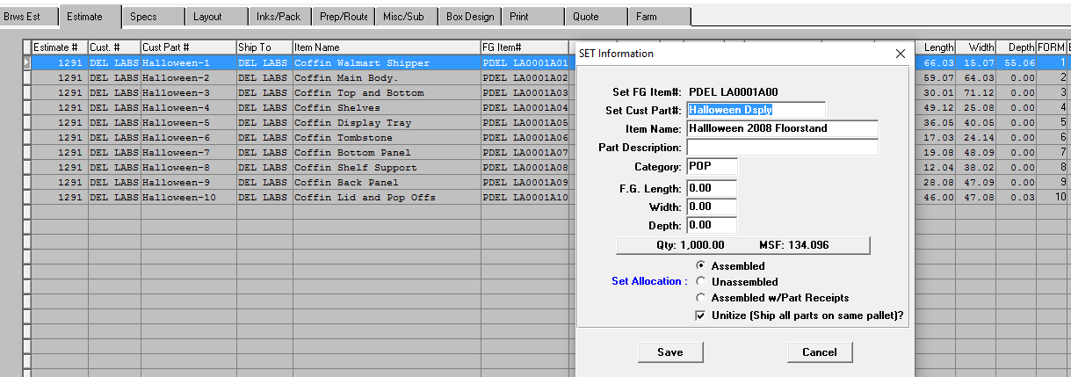

**Sets within Sets = Yes**



**FORM 0-0 For Assembled Set Unitization and Freight**

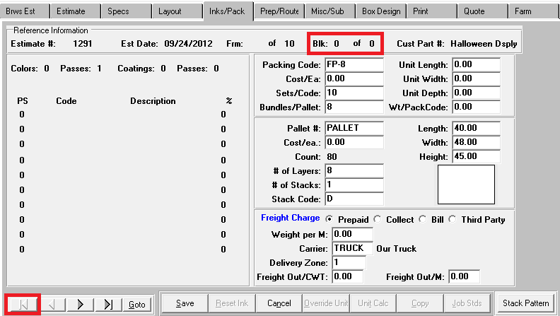

**CORRUGATED ESTIMATING OPTIONS - PARTITIONS Estimate 1432**

1. Partitions with Style Type P
2. Freight and Packaigng Form 0-0 on Inks Pack Tab
3. Assembled & Unitited vs Unassembled Partitions

**Assembled Sets Set Button**

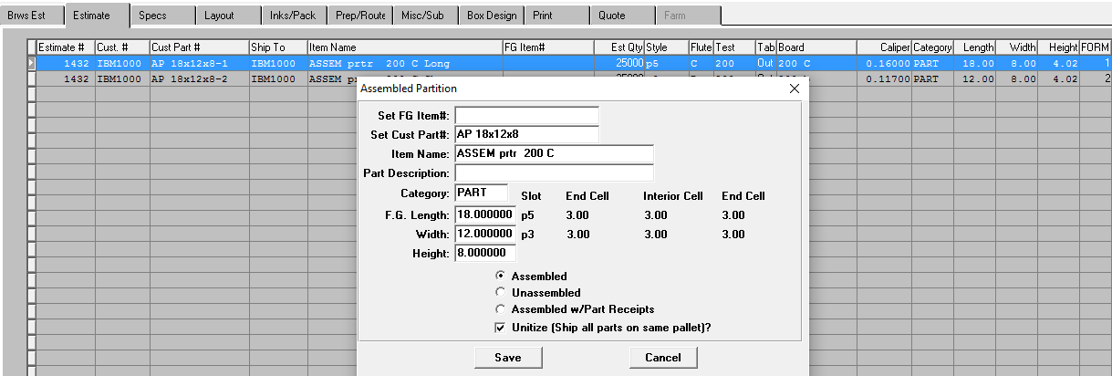

**Box Design Showing, 2D, 3D. Cad and Graphis Images**

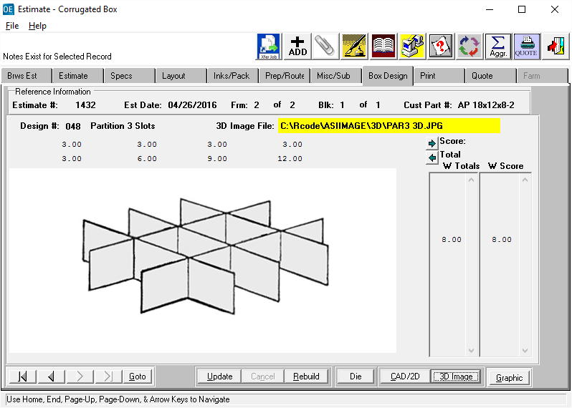

**CORRUGATED ESTIMATING OPTIONS - 2D & 3D FOAM - Estimate 945**

1. Style Type = F for Foam
2. Raw Material Types 1, 2, 3 and 4 Only.
3. Layout Tab has Width, Length and Depth Number Outs
4. Layout Tab has Unlimited Passes for RC & DC Departments
5. Routing Tab allows for Multiple Passes for RC & DC Departments

**Layout Tab Showing Multiple Passes**

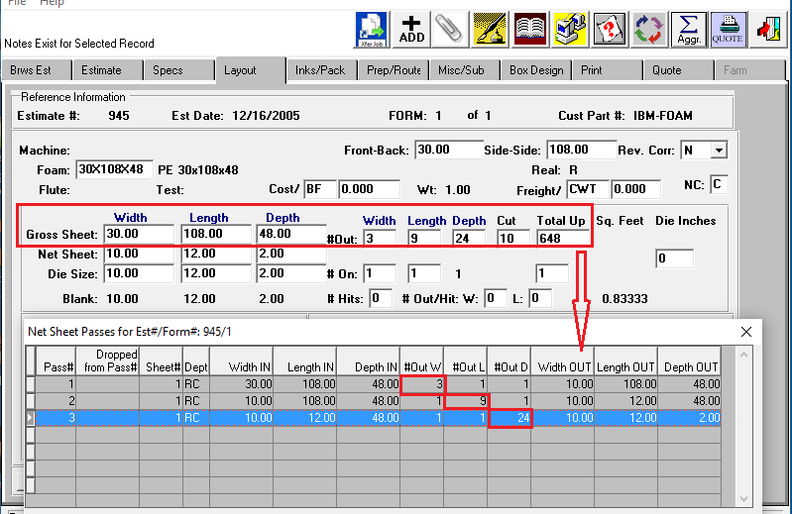

**Routing Tab Showing Multiple Passes**

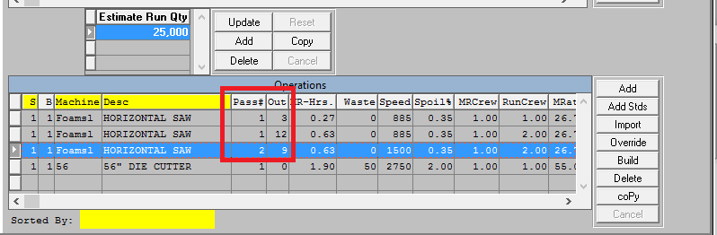

**CORRUGATED ESTIMATING OPTIONS - Estimate 1435 Combination / Gang Jobs**

1. Unlimited Items per Sheet
2. Unlimited Sheets-Forms per Estimate
3. Cost per Sheet for Sheet Fed and Cost per Blank for Blank Fed Machines

**GOTO Button Showing 2 Blanks per Sheet**

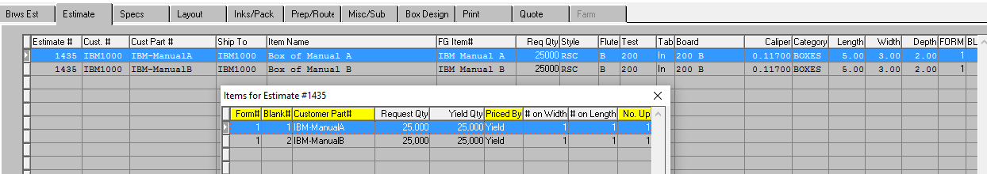

**LAYOUT TAB Showing 2 Blanks per Sheet**

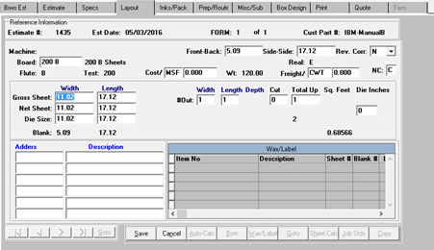

**PREP / ROUTING Tab showing Separate Plates and Gluers per Item**

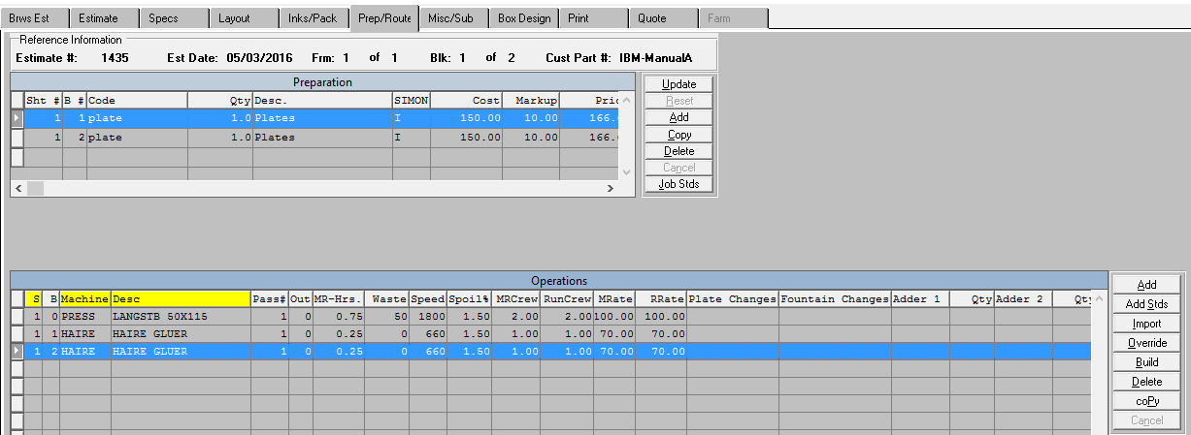

**CORRUGATED ESTIMATING OPTIONS Estimate 1436**

**BOM Button for Corrugators & Angle Board as a Corrugator**

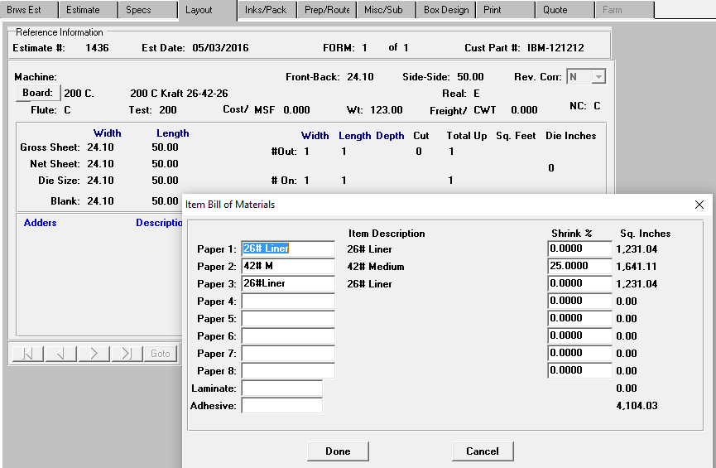

**Routing Tab for Corrugators & Angle Board as a Corrugator**

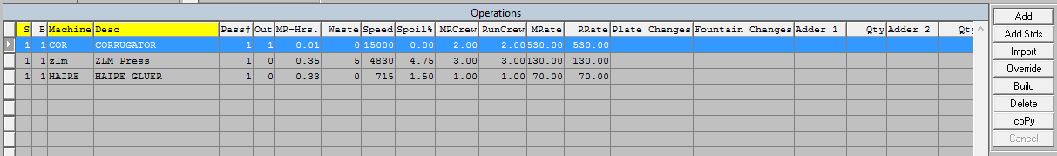

**Estimate Print Out Materials for Paper (Option to Show Cost of Rolls or Cost as 200C Sheets)**

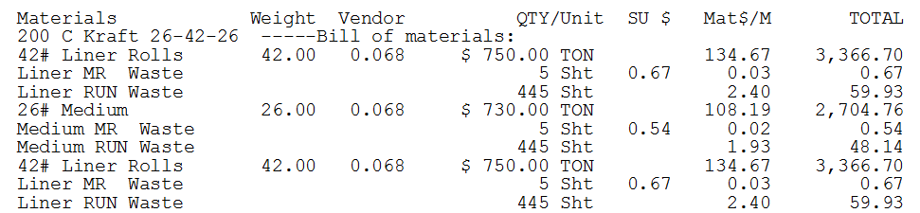

**CORRUGATED ESTIMATING OPTIONS - FARM OUTS Estimate 986**

1. Same Estimate Specifications as Manufactured Except P/M = Purchased
2. Machine Department = FO and FARM TAB Options
3. Layout Tab Defaults Board to Non Chargeable
4. Routing Tab Defaults to Machine with Department FO with No Cost
5. FARM Tab houses Finished Goods Costs by Vendor
6. Eliminating Materials Waste Costs from Farm outs N-K-1 CECPURWAS

**Estimate Tab showing Purchased/ Manufactured Field** 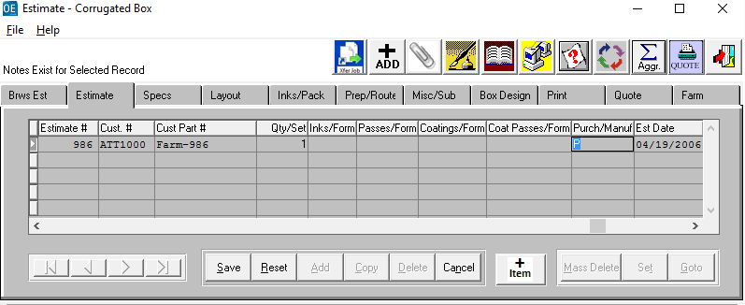

**FARM Tab houses Finished Goods Vendor Cost Matrix**

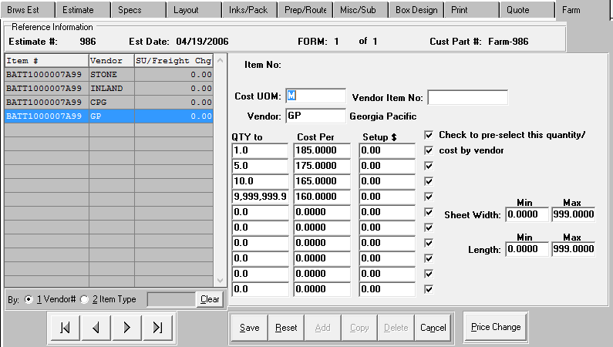

**ESTIMATE TAB GENERAL FEATURES Estimate 1431**

1. Shipto Code automatically populates PACKS tab
2. **+Item Button** to Automatically Assign FG item per logic of N-K-1 FGITEM#
3. F1 on Quantity Field to Allow 28 Quantities per Esimate
4. Number of Colors automatically Populates INKS Tab
5. Postive Qty per Set is Multiplied By Estimate Quantity /
6. Negative Qty per Set is Divided By Estimate Quantity
7. Set Y/N for Sets in Sets (For example 2Piece Box part of Assembled Partition Set)
8. **GOTO Button** for Gang Jobs
9. **Set Button** for Sets, Kits, Displays and Partitions

**Estimate Tab**

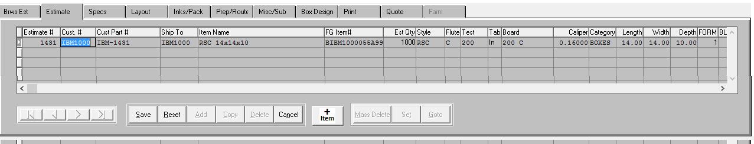

**SPEC TAB GENERAL FEATURES Estimate 1431**

1. AutoCalc Button
2. Override Button
3. Binoculars - Importing via Cad Files (N-K-1 CadFile)
4. Binoculars – Importing Die Files (N-K-1 DieFile)
5. Add Plates & Dies on the Fly (N-K-1 AddPrep)
6. Binoculars for Die Images
7. Binoculars for Cad Images
8. Overriding Score Panels and Score Types

**SPECS Tab**

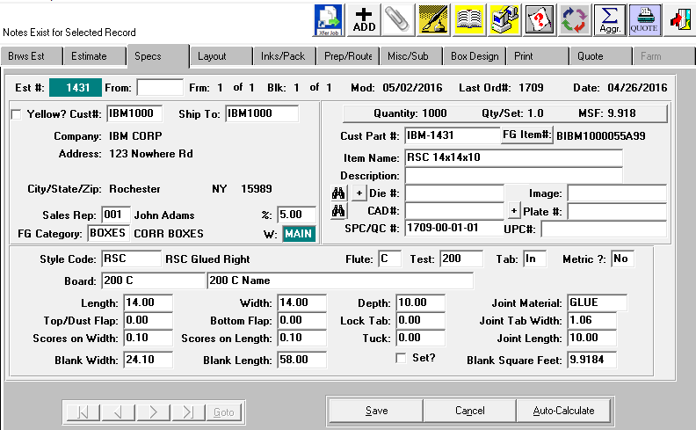

**LAYOUT TAB GENERAL FEATURES**

1. **AutoCalc Button** to Calculate Number up and Machine Trim
2. **Sheet Calc Button** to Find Stock Sheets by Minimum Waste
3. Adder Charges
4. Litho Lable Glue and Wax Glue Matrix
5. **Job Standards Button** to Transfer Changes to Job File for Job Ticket

**Layout Tab showing Sheet Size, Blank Size and Layout**

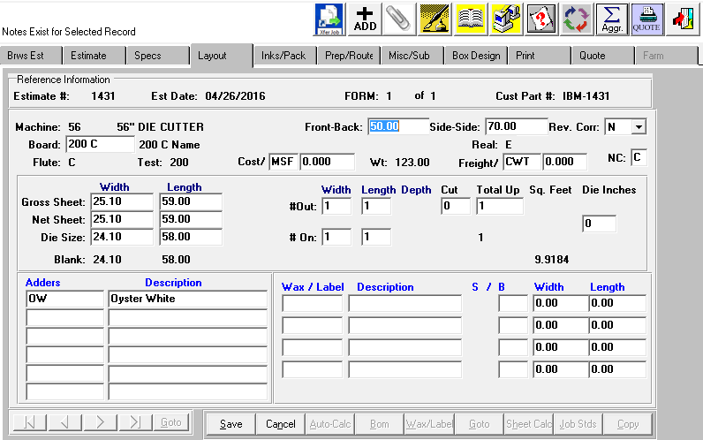

**INKS / PACK TAB GENERAL FEATURES**

1. Color Description Field prints on Quote Form.
2. F1 On Color Code to Select Multiple Inks
3. Bundle and Pallet Calculation by logic from N-K-1 CECUnit
4. Override Unit Button to Change Counts and Freight Costs

**INKS Tab**

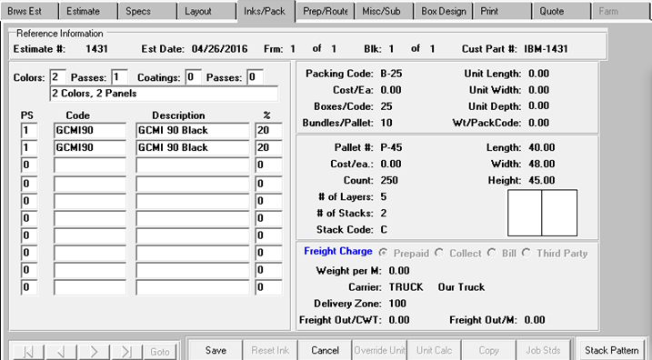

**OVERRIDE UNIT BUTTON (N-K-1 CECUnit)**

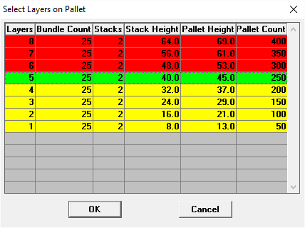

**PREP / ROUTE TAB GENERAL FEATURES**

1. Default Plates per Color from E-B-Prep File
2. Prep SIMON Codes
3. Prep, Plates, Dies Markup Profit or Cost (N-K-1 CEPrepPrice)
4. Prep, Plates, Dies Selling Price Round Dollars (N-K-1 CEPrep)
5. OVERIDE Button - Change #Out, Setup, Run Speed & Spoliage.
6. Overriding Number Out and Machine Standards (N-K CEROUTE#OUT)
7. Machine Standard Code 30 Routing # Out imports machine standards by Routing # Out.
8. Multiple Routings by Estimate Quantity
9. Plate and Fountain Changes for MR/Setup Calculation for Back to Back Jobs
10. Machine Attachments for Hand Holes, Partition Dies, etc.

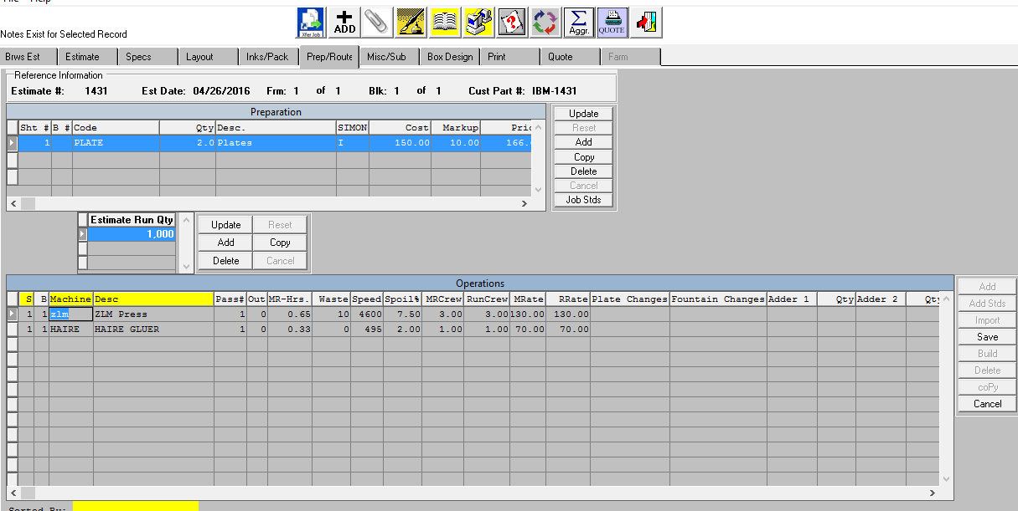

**PREP / ROUTE TAB GENERAL FEATURES - Estimate 1431**

**ROUTING TAB – JOB TRANSFER BUTTON**

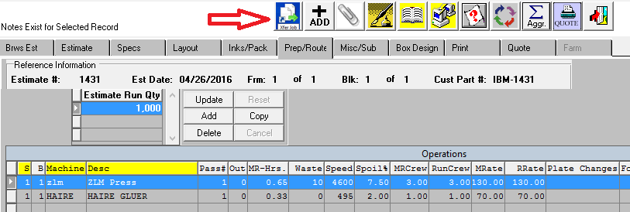

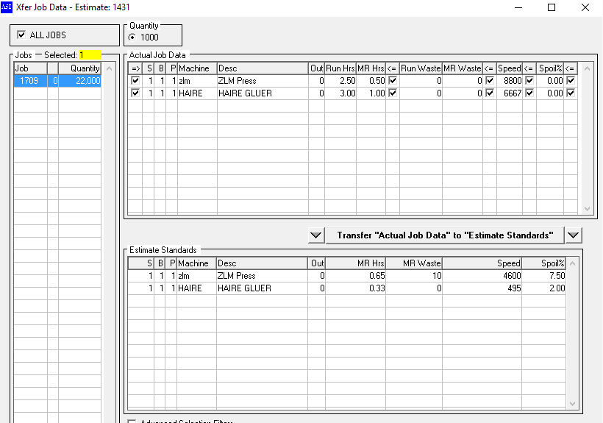

**MISCELLANEOUS / SUB-CONTRACT GENERAL FEATURES**

1. Manually Typed Outside Costs for Labor or Material
2. Lookup Materials predefined in Raw Materials File
3. Quantity per Set multiplied by Estimate Quantity

**MISC / SUB Tab**

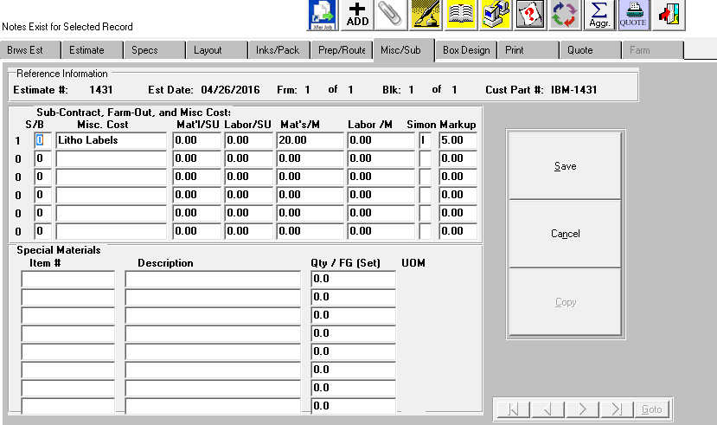

**BOX DESIGN GENERAL FEATURES**

1. Box Design transfers from Box Design File via Style File
2. Manually Import Cad Image from Adobe Illustrator, Paint, Photoshop, etc.
3. Spec Tab Cad Binocular Icon Transfers to Box Design Cad/2D Image
4. Spec Tab Die Binocular Icon Transfers to Die Image
5. 3D Image Transfers from Style / Box Design
6. Graphics .PDF image tied to Finished Goods Item
7. Score Allowances and Box Designs Updateable.

**Box Design Tab**

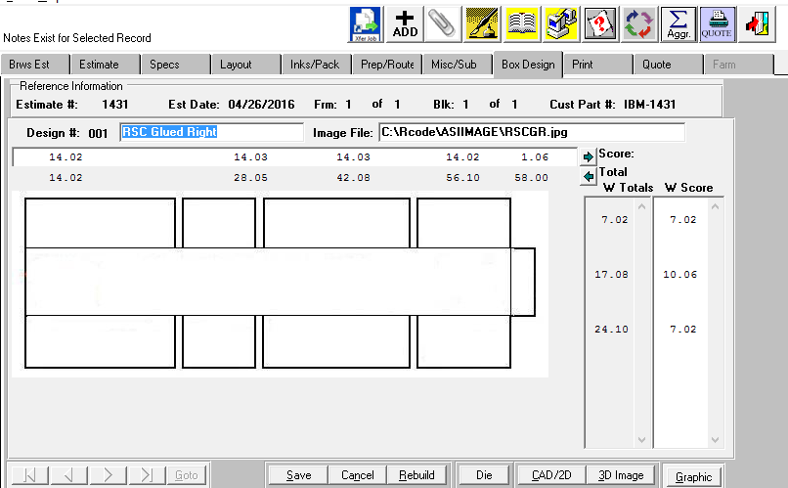

**PRINT TAB GENERAL FEATURES**

1. CALCULATE Button
2. Override GS&A
3. Override Warehouse Chargers N-K-1 CEWhsChg
4. Select by Board Vendors N-K-1 CEVENDOR  
   Limit acccess by User Group, Product Category & Vendor
5. Estimate Price to Round Up to Penny, Dime or Buck N-K-1 CEROUND
6. Material Default Markup N-K-1 CeMat’l
7. Miscellaneous Material Default Markup N-K-1 CeMat’l
8. WHATIF Button Sell Price by Cost or per MSF N-K-1 CEWhatif
9. IMPORT Button to import Prices from Last Quote
10. QUOTE Button to Transfer to Quote History
11. SPEC/NOC to Print Estimate Spec Sample Data N-K-1 CESample

**PRINT TAB**

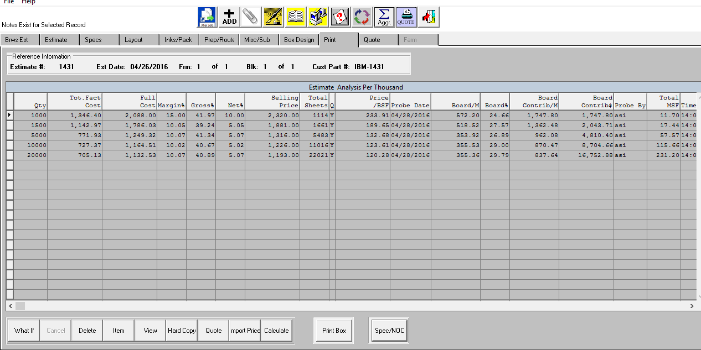

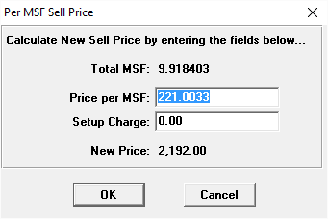

**PRINT TAB GENERAL FEATURES**

**HARD COPY BUTTON**

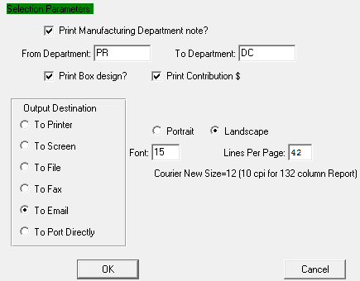

**ESTIMATE PRINT OUT - N-K-1 CEPrint, CEC**

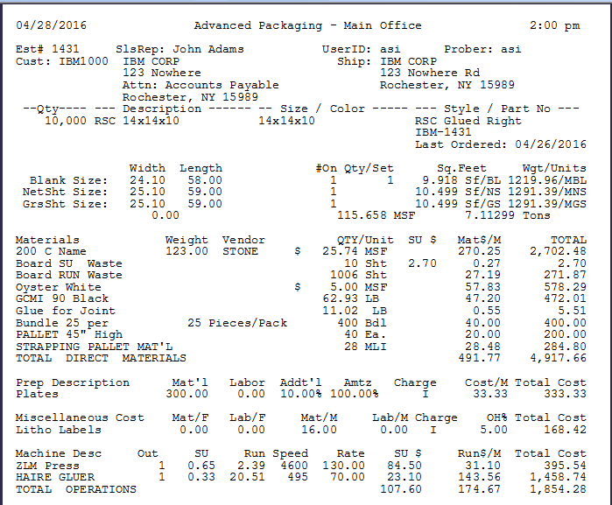

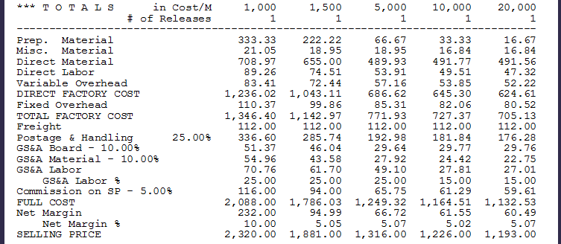

**QUOTE TAB GENERAL FEATURES**

1. Quote Notes Default Quote# N-K-1 QuoNotes
2. Default Quote Price M or EA By Customer N-K-1 QuoPrice
3. Quote Price Check vs Orders Price
4. Orders without Est # for FG items with Estimates N-K-1 OEPriceCheck

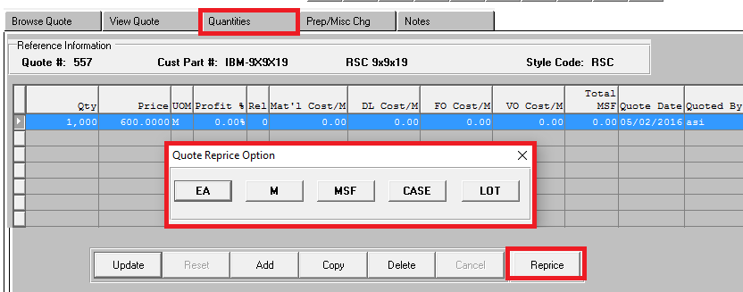

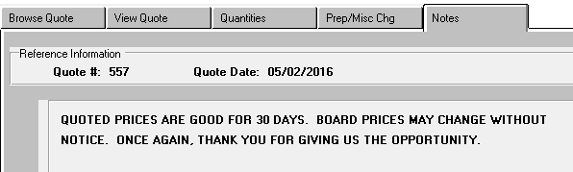

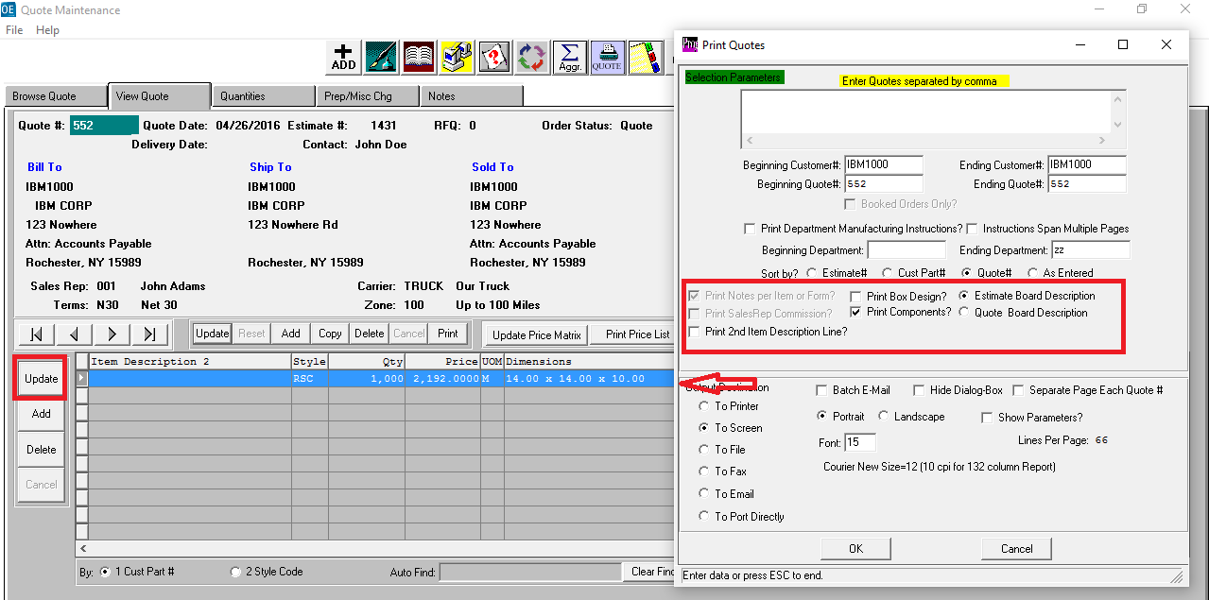

**QUOTE SHEET GENERAL FEATURES** (N-K-1 QuoSheet)

1. Add Quotes for Finished Goods Items without created Quotes
2. Create a Price Sheet for Clients to Order
3. Import Invoices Prices or Quoted Prices

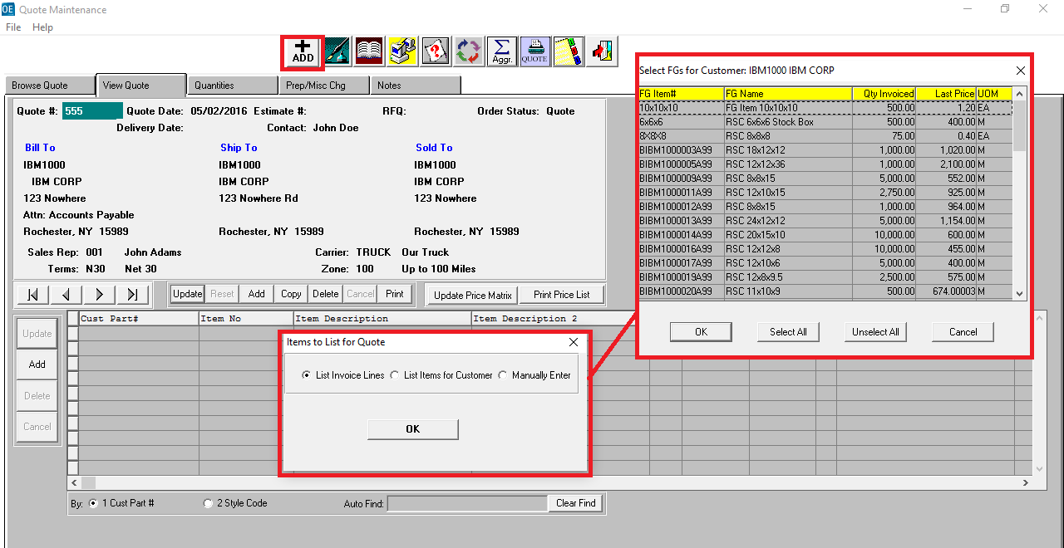

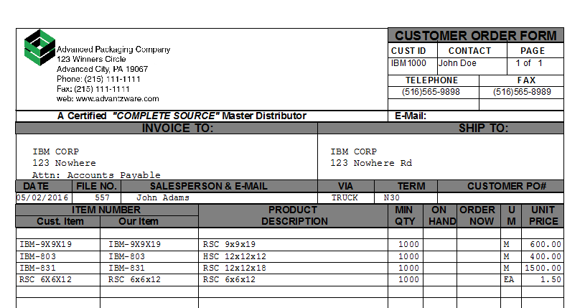

**QUOTE GLOBAL PRICE CHANGE GENERAL FEATURES**

1. Updated Quote History Price Increases or Decreases
2. Updated Quote History by Board Code
3. Updates Quote History by Customer
4. Updates Quote History by Customer
5. Raw Material Increases update newly calculated estimates
6. Raw Material Increases do not update Quote History

**Global Quote Price Change**

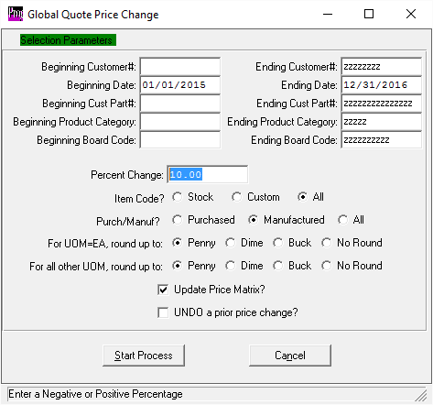

**FILE MAINTENANCE GENERAL FEATURES - Machine Attachments**

**Machine Attachments**

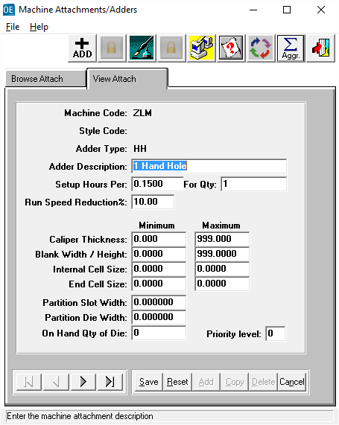

**Machine Routing Tab to Enter Machine Attachments**

Partition Dies import based on Dies Limitation based on N-K-1 CEPDies

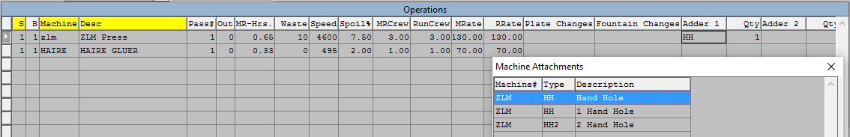

**FILE MAINTENANCE GENERAL FEATURES - Prep, Plates and Dies**

1. Default Prep Master N-K-1 PREPMASTER
2. Default Plate / Print Die Bin Location N-K-1 PREPPLBIN
3. Default Plate GL Account # N-K-1 PrepPLGL
4. Default Cutting Die Bin Location N-K-1 PrePDieBin
5. Default Cutting Die GL Account # N-K-1 PrepDieGL

**Prep File**

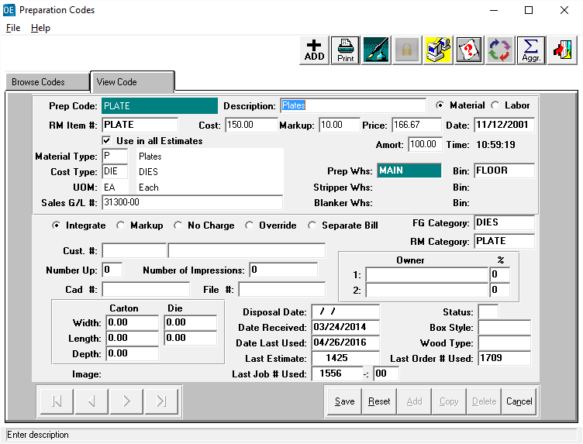

**FILE MAINTENANCE GENERAL FEATURES - Control File Markups**

1. Default Materials in Not Defined by Style
2. Handling Charge Markup for Manufactured Items
3. Handling Charge Markup for Farm Out Items
4. Warehouseing Markups
5. Broker Commission Default
6. Special Markups by Dollor or Percentage
7. Sell Price by Net, Gross or MSF
8. General Selling & Admin (GS&A) Markup Matrix by Material and Labor
9. Options to Show Commissions, Rates and Costs in Full or Factory Costs.

**Estimate Control Tab**

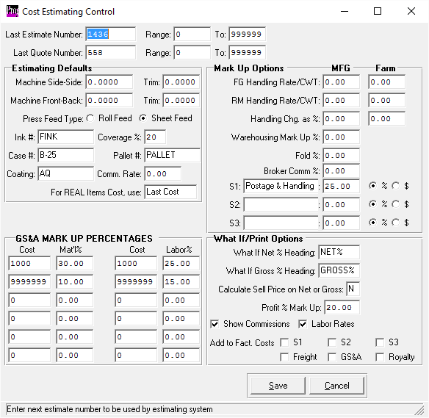

**FILE MAINTENANCE GENERAL FEATURES - CARRIER / TRUCK FILE**

**TRUCK FILE for Freight, Minimim Charge and Truck Routing**

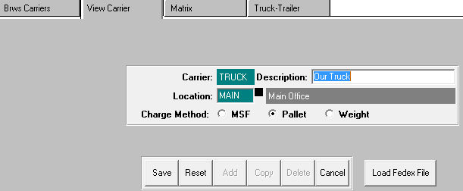

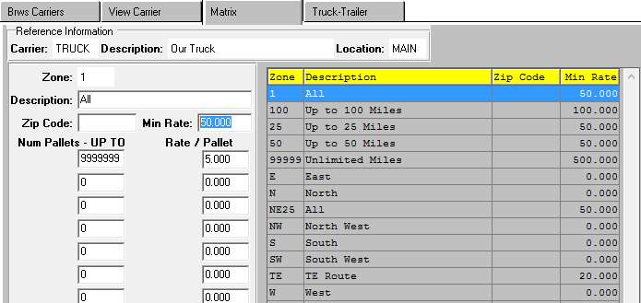

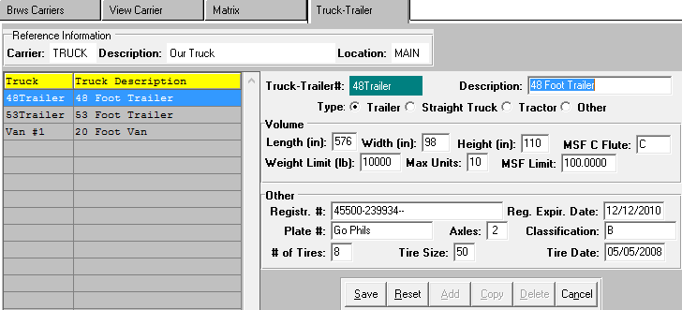

**FILE MAINTENANCE GENERAL FEATURES - Machine File**

**Machine Standards Tab - N-Z-7 for Latest X-Y Matrix Options**

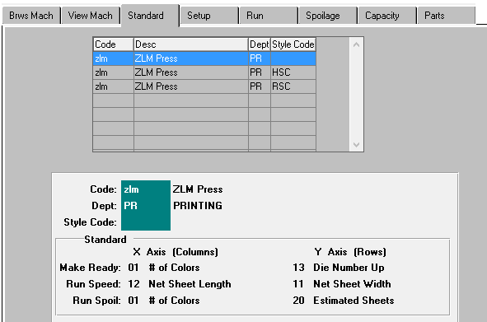

**Machine Parts Tab**

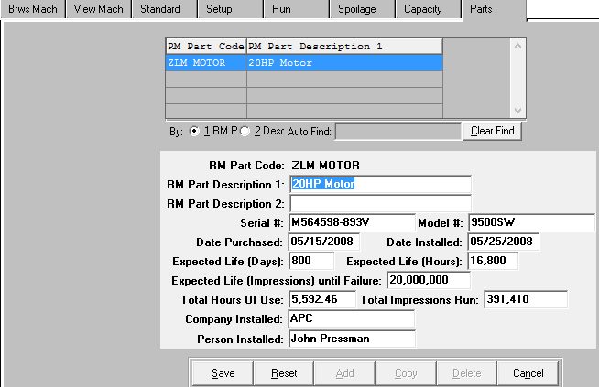

**FILE MAINTENANCE GENERAL FEATURES - SCORE TYPES**

1. Score Types for Purchase Order Integration
2. Used in Style File
3. Option to Update on Estimate Spec Tab

**Score Types**

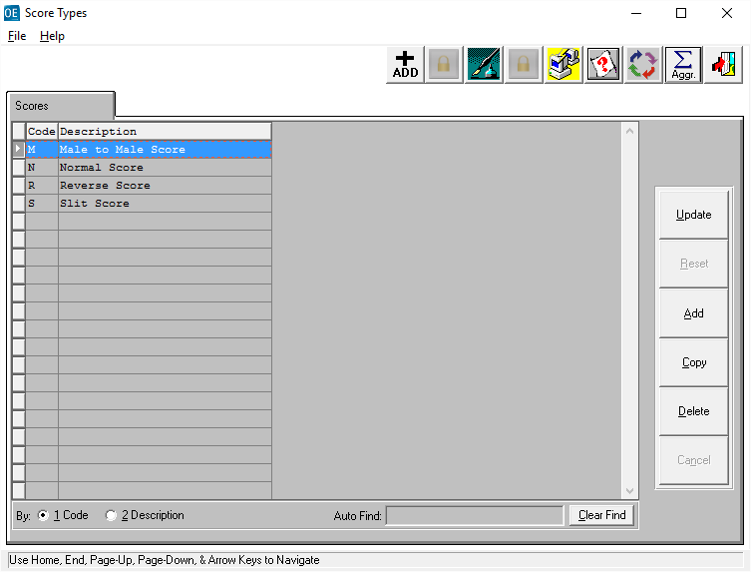

**FILE MAINTENANCE GENERAL FEATURES - STACK PATTENS**

1. User Defined Patterns
2. Banding Material Costs for Material Type = J
3. Formula to Calculate Total Inches of Banding
4. Unit Pattern Image Transfers to Estimate
5. Unit Pattern Image Transfers to Job Ticket

**STACKING PATTERNS**

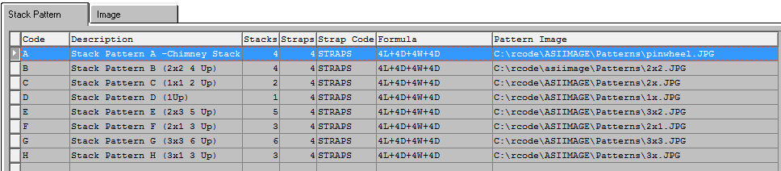

**Images Stored on Disk Drive**

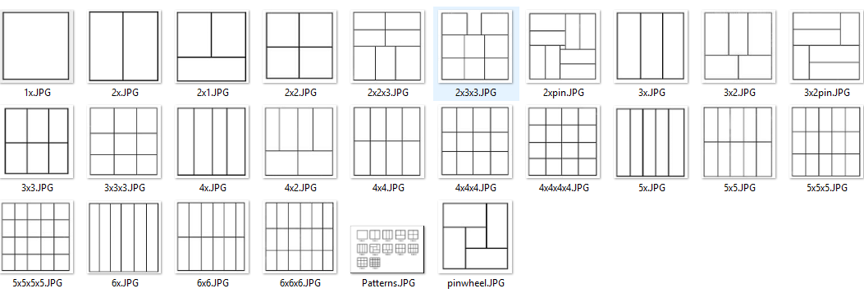

**FILE MAINTENANCE GENERAL FEATURES - STYLE FILE**

1. Style Types B = Boxes, F= Foam, P= Partiions, D=Die Cuts
2. Default Joint Dimensions
3. Score Allowance by Flute Code
4. Default Materials and Default Machines
5. Default Slots for Partitions

**Style Tab**

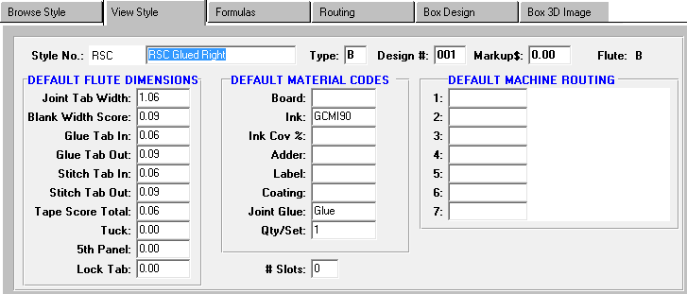

**Style Formulas Tab**

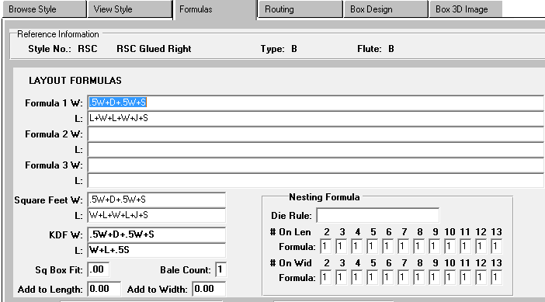

**FILE MAINTENANCE GENERAL FEATURES - STYLE FILE**

1. Style Types B = Boxes, F= Foam, P= Partiions, D=Die Cuts
2. Default Joint Dimensions
3. Score Allowance by Flute Code
4. Default Materials and Default Machines
5. Default Slots for Partitions

**Style Routing Tab**

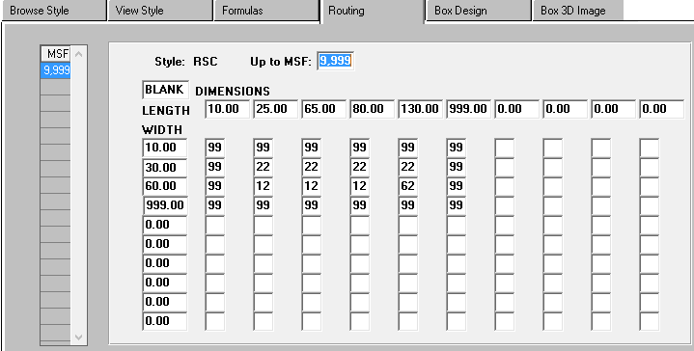

**Style Box Design Tabs**

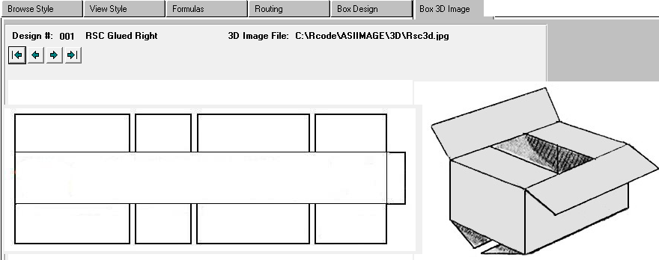

**ESTIMATING REPORTS - Popular Reports**

**E-R-5 Estimates List to Show Unbooked Estimates**

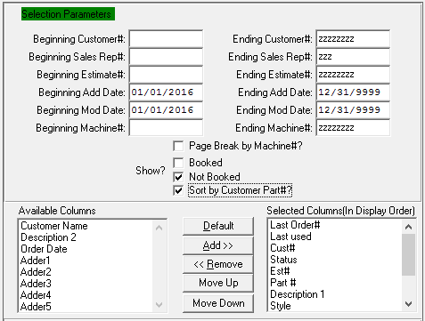

**E-R-7 Prep List by Material Type to Show Old Plates and Dies**

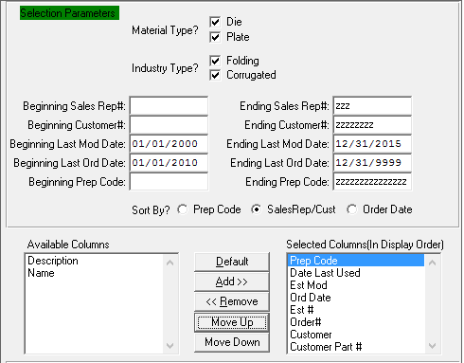

**ESTIMATING REPORTS - Popular Reports**

**E-R-8 Estimates by Size**

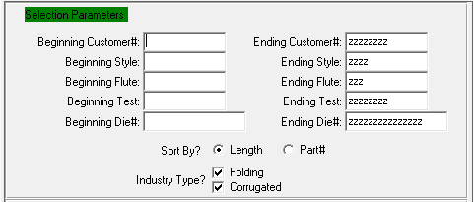

**E-R-8 Quotes Price List**

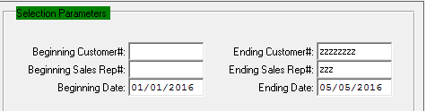

**E-R-10 Estimates List with Multiple Margins**

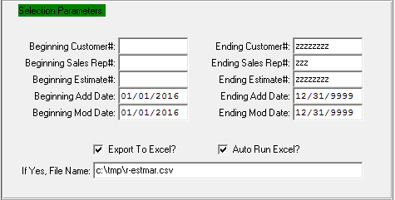

**ESTIMATING STANDARDS REPORT - TO UPDATE ESTIMATE STANDARDS**

**D-R-14 W.I.P Standards Details by Style, Size, etc.**

